5th Grade – Unit 2

Informative/Explanatory Writing

Bubblology

STUDENT PACKET

Name: __________________________________ Date: __________________

Directions:

Today you will read a passage about bubbles.

You will then answer several questions based on the passage.

You will notice as you answer the questions that some of the questions have two parts. You should answer Part A of the question before you answer Part B.

After answering the questions, use information from the article to write an informative essay explaining what is the same and what is different between big bubbles and small bubbles.

Your Writing Task:

Use information from the article titled “Bubblology” to write an informative essay explaining what is the same and what is different between big and small bubbles.

Be sure to use details from the article to support each part of your essay.

Bubblology
Retrieved from Achieve the Core

(bŭb’ l-ŏl -jē) n. The study of bubbles.

- There is a lot to be learned from a bubble! Bubbles can teach us about life, light and strength. The wall of a bubble has three parts. There is an outer wall made of soap or detergent, a center wall made of water, and an inner wall that is also made of soap or detergent. The inside of the bubble is filled with air. This structure of the bubble’s wall is very similar to that of membranes found in living creatures like us.

- Did you ever wonder how the food you eat gets from inside your stomach to inside your muscles? To get to your muscles, the food must first be digested. Then it must pass through a set of membranes into your blood. The nutrients then circulate through your arteries to your muscles, where they pass through another set of membranes into your muscles. The next time that you blow bubbles, look for a cluster of them, and watch closely. If they don’t pop too quickly, you will see that the air from the smaller bubbles will pass through the bubble wall into a larger bubble on the other side. This is very similar to the way that oxygen passes from your lungs through a membrane and into your blood stream. The larger bubbles are sturdier, because their walls are not curved as much as the walls of smaller bubbles.

- Bubbles can also teach us about light. The light from the sun is made up of many different colors. Mixed together, they look white. However, it is possible to separate the different colors of light from each other with a prism. Small drops of water or ice crystals can work like a prism. You have seen this for yourself if you have ever seen a rainbow. The wall of a bubble can work the same way. That is why bubbles are iridescent. When light hits a bubble, it may look blue, or it may look red. The colors seem to dance around on the surface. The colors that we see depend upon the thickness of the wall of the bubble and how much it is bent. As water evaporates from the bubble, the bubble’s wall becomes thinner, and the colors change. Also, as the wind blows a bubble around, its wall bends, changing the color.

- Bubbles can also teach us how to make things stronger. Bubbles are usually very fragile. They can easily pop. But if we add sugar to the bubble solution, the bubbles are much sturdier. They will last for two or three times as long. This is because the sugar strengthens the wall of the bubble. The sugar dissolves in the water layer of the bubble’s wall and takes the place of some of the water. Since the sugar does not evaporate as quickly as the water, the bubbles last longer. In addition, the sugar molecules are very large and stiff compared to water molecules. Like a large board nailed to the wall of a house, the sugar molecules brace the wall of the bubble to make it stronger.

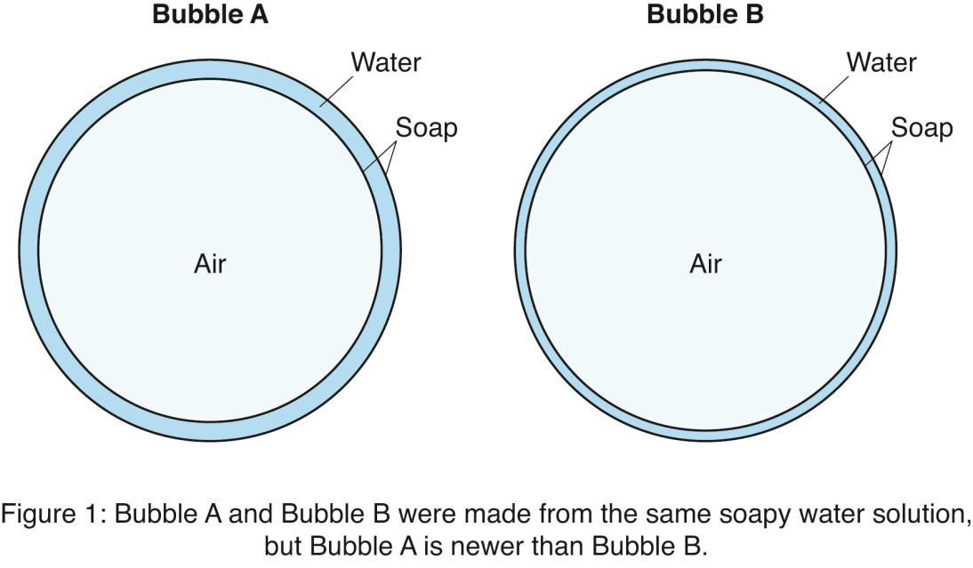

- Bubbles are pretty incredible, but who knew? The observations that people have made about them have led to many questions and interesting answers that help explain the world around us.

Reprinted with permission from Celebrating Chemistry. Copyright 2002 American Chemical

QUESTIONS:

- Based on information in the article, what are two ways that a bubble is like a membrane?

  - It has walls that curve.
  - It is very colorful.
  - It is thin and delicate.
  - It can separate light.
  - It lets substances pass through.
  - It lasts only a short time.

According to the article, which of the following bubbles would last the longest?

  - A small bubble before the air inside passes to a larger bubble.
  - A small bubble with thin, tightly curved walls.
  - A large bubble made with soap or detergent and sugar.
  - A large bubble with walls that bend in the wind and change colors.

The following question has two parts. Answer Part A and then answer Part B. Part A: In paragraph 4, what does the word brace mean?
  - fasten
  - prepare
  - support
  - awaken

Part B: Which two phrases from paragraph 4 best help the reader understand the meaning of brace?
- “can easily pop”
- “two or three times”
- “strengthens the wall”
- “dissolves in the water”
- “does not evaporate as quickly”
- “very large and stiff”

What does Figure 1 help the reader understand about bubbles?

  - Figure 1 shows that Bubble B is likely to pop soon because some of the water has evaporated.
  - Figure 1 shows that bubbles are usually the same shape and size.
  - Figure 1 shows that bubbles are fragile because they are made of only air, soap, and water.
  - Figure 1 shows that air can move from one bubble to another.

Using the ideas below from “Bubblology,” decide which two items on the list are main ideas from the article, and write them on the chart. Then use the list again to write in one supporting detail for each main idea you have chosen. One main idea and one supporting detail have already been written in the chart for you as an example. Note that you will NOT use all the details listed.

Details from “Bubblology”

- Bubbles act like prisms.  - Bubble walls are made of soap.  - Bubbles appear colorful.  - Bubbles with sugar last longer. | - Walls of houses are made strong with boards.  - Bigger bubbles are sturdier.  - Adding things to the soapy water can  strengthen bubbles.

Main Idea | Supporting Detail
Bubbles show a process that is similar to  something that happens in our bodies. | Air moves between bubbles.

- The following question has two parts. Answer Part A and then answer Part B. Part A: What is the main point the article makes?

  - The structure of bubbles makes them quick to pop.
  - Many things can affect a bubble’s color and strength.
  - Bubbles can be used to help explain several science concepts.
  - Living creatures have bubble-like structures in their bodies.

Part B: How does the structure of the article help support the answer to Part A?

- The article demonstrates how bubble walls are like membranes, prisms, and the walls of houses.

- The article explains the causes and effects of making bubbles last longer.
- The article uses chronological order to examine the effect of light and wind on bubbles.
- The article presents the steps involved in the process of human digestion.

In paragraph 1, the author says that bubbles can teach us about life.

Circle the sentence in paragraph 2 that provides evidence for this claim.

Your Writing Task:

Use information from the article titled Bubblology to write an informative essay explaining what is the same and what is different between big and small bubbles.

Be sure to use details from the article to support each part of your essay.

Informative/Explanatory Essay

______________________________________________
__________________________________________________________________________________________________________________________________________________________________________________________________________________________________________________________________________________________________________________________________________________________________________________________________________________________________________________________________________________________________________________________________________________________________________________________________________________________________________________________________________________________________________________________________________________________________________________________________________________________________________________________________________________________________________________________________________________________________________________________________________________________________________________________________________________________________________________________________________________________________________________________________________________________________________________________________________________________________________________________________________________________________________________________________________________________________________________________________________________________________________________________________________________________________________________________________________________________________________________________________________________________________________________________________________________________________________________________________________________________________________________________________________________________________________________________________________________________________________________________________________________________________________________________________________________________________________________________________________________________________________________________________________________________________________________________________________________________________________________________________________________________________________________________________________________________________________________________________________________________________________________________________________________________________________________________________________________________________________________________________________________________________________________________________________________________________________________________________________________________________________________________________________________________________________________________________________________________________________________________________________________________________________________________________________________________________________________________________________________________________________________________________________________________________________________________________________________________________________________________________________________________________________________________________________________________________________________________________________________________________________________________________________________________________________________________________________________________________________________________________________________________________________________________________________________________________________________________________________________________________________________________________________________________________________________________________________________________________________________________________________________________________________________________________________________________________________________________________________________________________________________________________________________________________________________________________________________________________________________________
You may use the space below to include an illustration.

Be sure to revise and edit your work!

